October 2020
Florenceville Middle School

Upcoming Events
October 2020
7th – Newsletter
12th – Thanksgiving – No School
27th – Picture Day
17th –23rd – Safe Schools Week
November 2020
2nd – 6th – Career Week
4th - Newsletter
11th – Remembrance Day – No School for students
16th – 20th – Diversity and Respect Week
20th – Teacher PL – No School

Did you know…
To be as healthy as possible, children need adequate nighttime sleep. Current guidelines recommend 9-11 hours of sleep per night for children ages 5-13 years old.

But…1 in 4 children are NOT getting enough sleep!

Over time, insufficient sleep impacts how a child feels, behaves, and interacts. 21.5% of children that get insufficient sleep report stress compared to 10.3% who get adequate sleep.

Catching more zzz’s can help with children’s physical health, emotional well-being, and quality of life!

For more information, go to https://www.canada.ca/en/public-health/services/publications/healthy-living/canadian-children-getting-enough-sleep-infographic.html

8794 Main Street, Florenceville-Bristol, NB E7L-3G2
FMS.nbed.nb.ca 506-392-5115
It’s hard to believe that October is already here! Along with beautiful fall colours that we see comes cooler weather requiring warmer clothing!
We have spent much of September reviewing the routines and procedures that allow us to conduct ourselves safely as we move throughout the building. We remind students often that in a home of over 200 people, we must have different routines and procedures than a home of 4 or 5. We have spent time practicing moving throughout the building, ensuring that we are responsible for ourselves and our belongings, and learning how to be kind to others, as well as the building.
Students sometimes struggle to meet these expectations, and through a positive behavioural support lens we find opportunities to reteach, review and practice, as well as teach replacement strategies. We appreciate your continued support and understanding in these areas.
Throughout the next few months, we will continue to review and focus on these expectations. Practice makes progress!
Ms. Rioux, Ms. Pearson, and the FMS Staff

Poinsettia Fundraiser
It is that time of year again! We are pleased to bring you beautiful poinsettias, Christmas cactus, frosty ferns, and cyclamen from Jolly Farmer! Sadly, the mini poinsettias were not an option this year. Envelopes and order forms arrived home last week. Please consider purchasing plants or asking family and friends to support us as well! This year, families who submit orders will be asked to pick up the entire order to reduce the number of people coming to the school.
The monies from this fundraiser helps to offset the costs associated with athletics, band and drama, field trips, as well as to purchase necessary items such as technology and equipment for student use. All remaining funds will be used for Educational purposes. In the near future we will set a day and time for pickup; it will be one day only and will take place during the last week of November.

Contact Information
Please continue to inform the school of changes to your contact information. If you have a change in email or phone number, it is imperative that you keep us updated by calling Miss Sally at 392-5115 or by sending in a note to the homeroom teacher. If you are not receiving talk mails, let Miss Sally know as well!

End of Day Routines
Please be reminded that students are only able to have one drop-off location by bus this year. If this needs to change, please call transportation at 325-4498 5 days in advance. Students are not allowed to walk off campus unless they are going home (usual walkers only). Please send a note in your child’s agenda if they are being picked up at the end of the day. Thank you for helping our students be safe!

Masks
Important! FMS is a nut free as well as a scent reduced facility!

Upcoming Events

Picture Day
Smile! Don’t forget that picture day is coming up – Thursday, October 27th.

sports
Thank you to Mme. Frenette for supporting our students with Cross Country!

Stay tuned for information regarding the next sport – Badminton! Please note - There will be changes due to Covid-19 restrictions.

We are pleased that our Falcons have been doing well with wearing their masks when required here at FMS. This is a quick reminder that every student is to have two masks with them at school. Below you will find a helpful visual referring to the correct way to put on your mask:
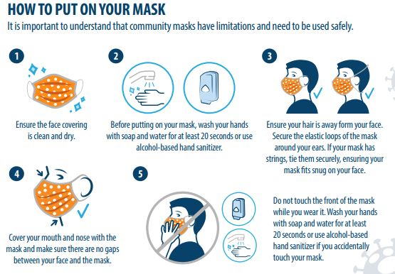

Protocols for Illness while at School
As part of our COVID-19 Operational Plan, any student who is ill while at school will be sent to the office to call home and asked to wait for a parent or guardian to pick them up within the hour. It is expected that parents/guardians will have a plan in place to pick up their child if they fall ill at school. As per provincial protocol, parents will need to have their child tested for COVID19 when presenting with sufficient symptoms to require testing – please consult the COVID-19 Checklist that was sent home last month. If you are unsure as to whether testing is required, please contact 811 and follow the instructions provided.

Home and School
FMS Home & School is once again selling apples as a fundraiser in partnership with Dukeshire's Apples - Orchard Shade Farms (& supporting local at the same time!!)
This year, we are selling 5 lb ($9 per), 10 lb ($15 per), ½ Bushels ($23 per) and Full Bushels ($35 per) of Cortland & MacIntosh.
Orders with payment are due by Thursday, October 8th @ 6PM. E-transfers can be sent to fmshomeandschool@gmail.com
Pick up is ONE DAY ONLY: Wednesday, October 21st at the FMS woodshop shed between 4 PM and 7 PM.

Cafeteria Service
Our Cafeteria is up and running, and still selling lunch items only. We are working with Chartwells to adjust the online ordering system to identify between items ordered for nutrition break or noon. Though online ordering through cafzone.ca is our preferred method of ordering, we realize that for some families this may be challenging. If students need to order in a traditional manner using cash, they can fill out an order form for the entire week and pay with cash.
Otherwise, if you find that your child is in need of some support with lunches for a short period of time, please let us know by calling Miss Sally at 392-5115 or sending an email.

